Kate Walters’ blog
The Encyclopaedic Palace La Biennale di Venezia, 2013.
Travel from west Cornwall to anywhere far and exotic is usually problematic, as we are so far away from anywhere down here. But it is something you get used to, and living here is so good that it’s worth it. I had thought train to London (5 hours) then coach to Venice (30 hours) should be OK. Time to relax, read, not do anything in particular, relish the anticipation of the Biennale. The reality once on the coach from London at the crack of dawn on Bank holiday Monday was being squashed between a Lithuanian plasterer (very nice man) and a punk Frenchman from Lyon (also very nice) on the back seat (I have long legs so always look for a seat with good leg room). And then a delay of nearly 3 hours at the tunnel, so I was worried I would miss my connection in Paris to Venice. Arriving in Paris at last you have to check in again, which involves going into a sort of dungeon and queuing for some time, with all your luggage. Queuing again to get on the next bus (smaller and cramped with dirty broken seats)…..In Milan the police got everyone off the bus and searched it with a sniffer dog.
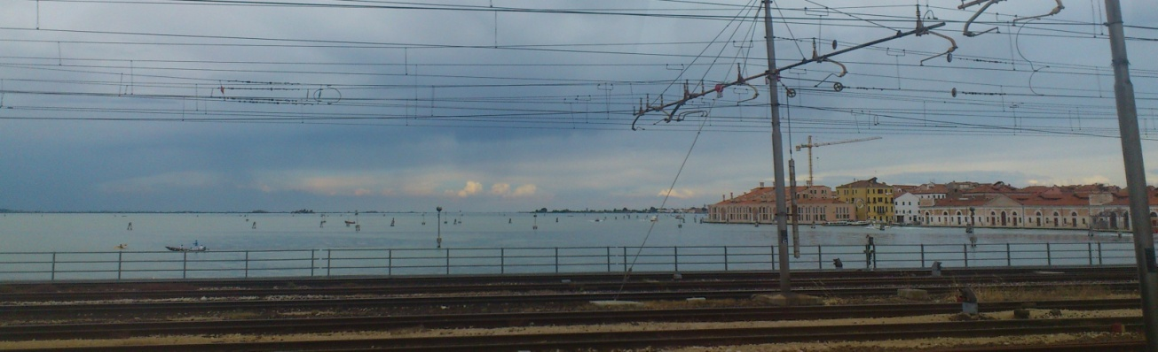
Once in Venice – with what exhausted joy! - I walked slowly past the station and eventually found my hostel, the lovely Ostello Santa Fosca, very peacefully situated at the end of a canal. I sat on old crumbling steps beside the water, beneath the sun, and waited for the door to open; I watched the swooping screeching swifts, thought of home. There were lollipop-shaped trees laden with sweet-scented blossom. It was lovely. After checking in, my feet carried me straight through the tiny streets to a favourite church, San Francesco della Vigne, instead of where I had been intending to go, which was the Arsenale. San Francesco della Vigne is a large Church set in a spacious and quiet square in the north of Castello, not very far from the Arsenale. (During the weekend preceding my departure I had read Geoff Dyer’s ‘Jeff in Venice and Death in Varanasi’ and I believe it was in this book that I discovered that on previous visits I had missed a special feature of this church – the glorious work by Giovanni Bellini, and the grassy courtyard reached through side doors. ‘Jeff in Venice’… also gave me some idea of what the Biennale parties could be like…I was soon to discover he hadn’t been exaggerating).
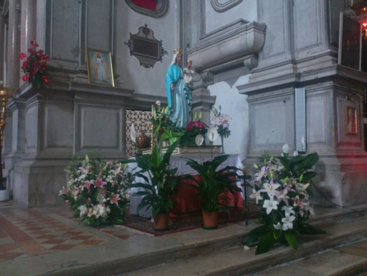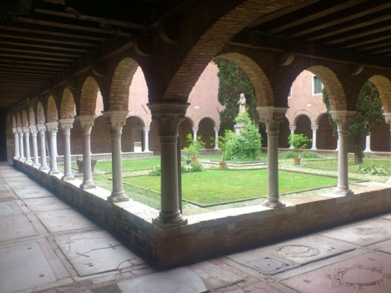
I was very glad to return to this church. The air felt thick with prayer around the statue of the Madonna. I could feel all my cells settling, moving towards stillness. I walked slowly around the church looking at each of the icons; I lit some candles, I had said I would.
After some time there I began my quest for the Arsenale. Having been to Venice on three previous occasions I had thought I would not get lost, but in fact I did lose my way, and found a kind man who took me all the way to the path I recognised. He was a Venetian, an architect concerned with the preservation of Venice; we had an interesting conversation about water levels and climate change.
The Arsenale was blissfully empty; I passed David Cotterell on the way there and he had told me it was the best time to visit, there being no queues. I got in easily with my invitation print out, and knew to expect something special in the first large area – the curators always seem to make a big statement here (I remember the vast candelabra of tampons from a few years ago). I wasn’t disappointed.
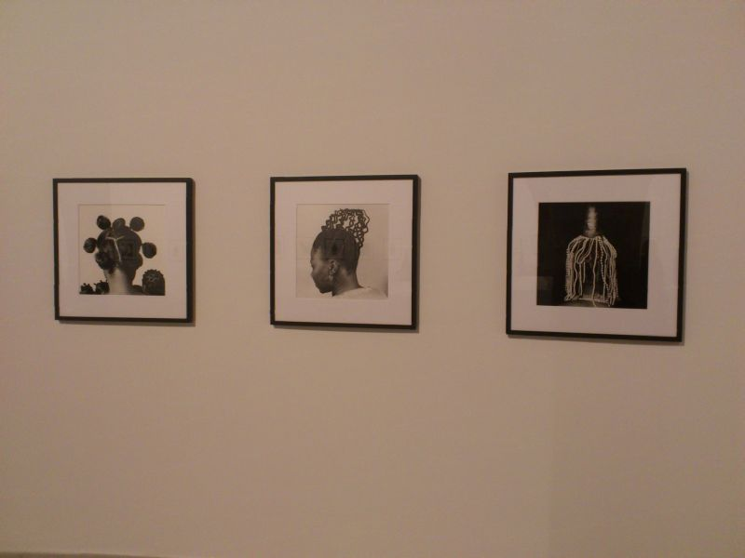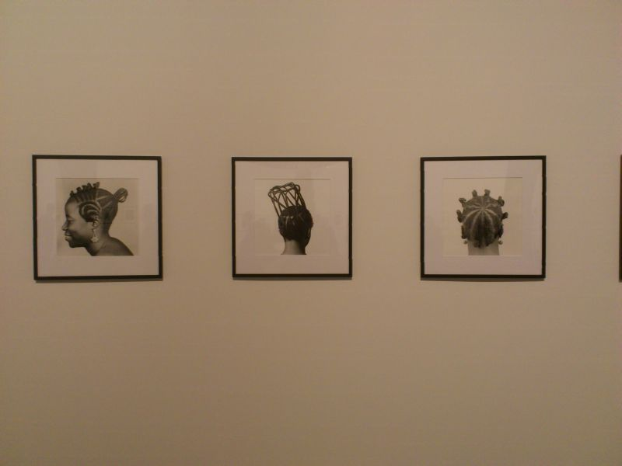
The monochrome photographs of the proud and stately women’s fine heads crowned with astonishing sculptural hair provided a halo around the central encyclopaedic palace model. It was fascinating to read about the man, Marino Auriti who had worked hard to make this work; he had been unknown, and had pursued a private and personal dream to build this object.
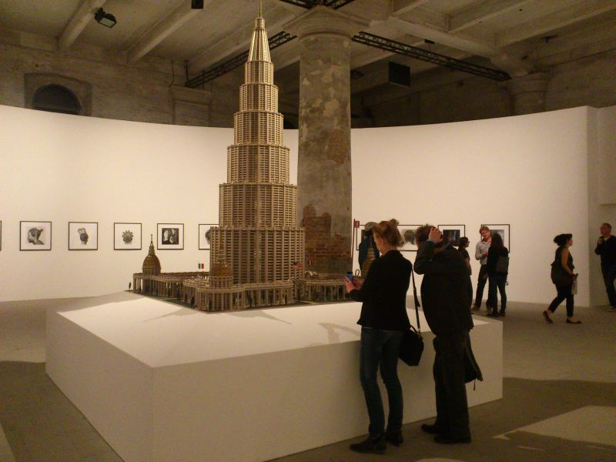
The curator Massimiliano Gioni was inspired by this and has based the entire biennale around this concept of the head, the extent of human knowledge- the limits to this also being suggested at various palazzi – the human encyclopaedic palace.
As an artist I tend to view big international shows with an eye towards where I can pick up clues for the development of my own work. I soon found works which had me thinking about using mud or clay to make large sculptural objects. But I was too tired to take in much on this first visit. Great to be here though, to feel the excitement!
I met up with some other artists from a-n and we headed off to a party near the Rialto Bridge at Palazzo Bembo.
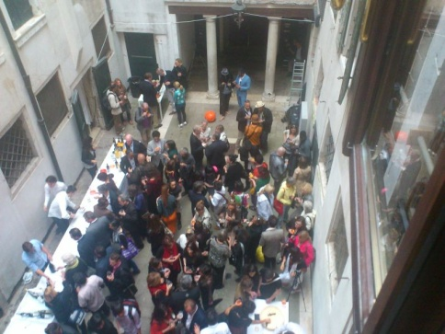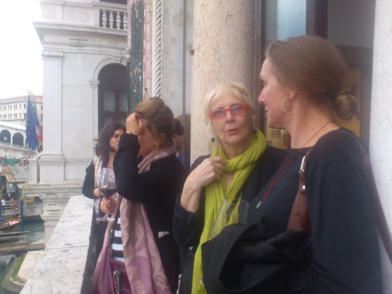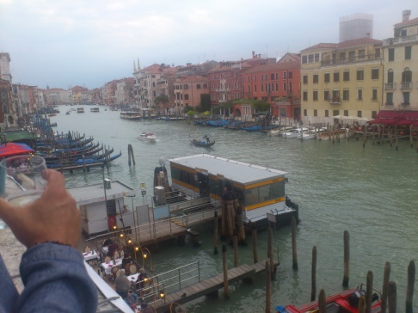
The scenes of Biennale parties I had read about days before suddenly came to life before me; as someone who only drinks at celebrations I was at a bit of a loss but then thought ‘oh well, this is a celebration’ and I queued for a large glass of prosecco.
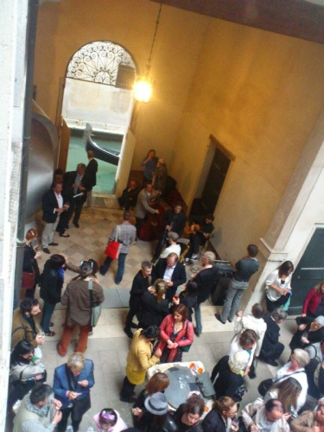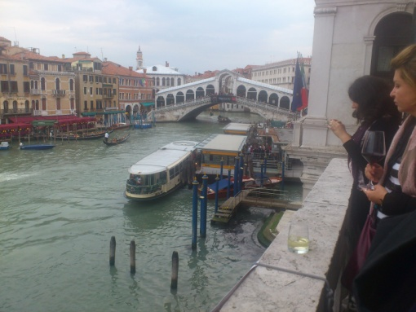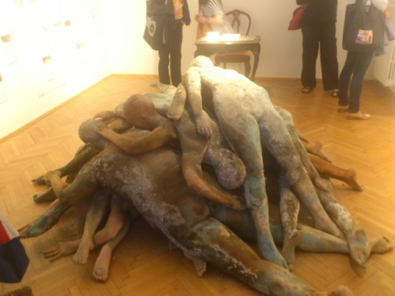
After that there is a bit of a blur! On my way home to the hostel I came upon another party on Strada Nove, so I went in and there was an almost identical scene laid out before me, same huge jeroboam of prosecco, enormous truckles of cheese, bread and enormous platters of smoked salmon. I wandered around, talked to some of the artists, the visitors, their dogs, and took many photographs.
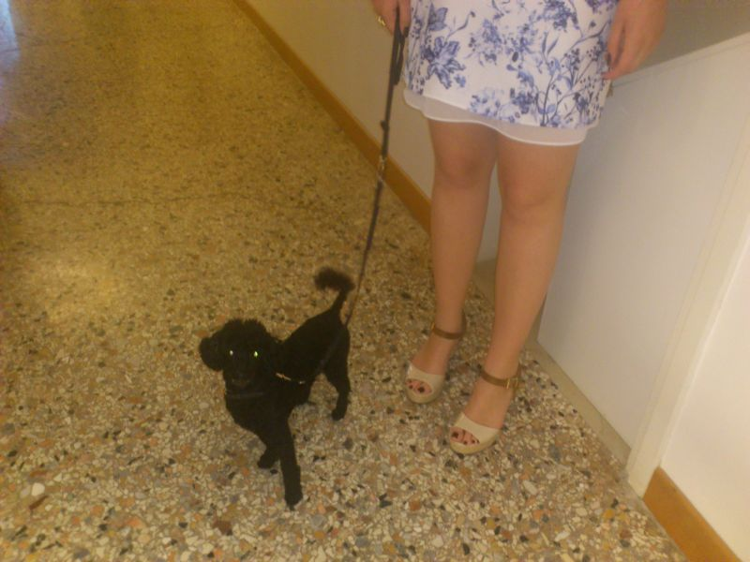
The following day, after dreaming of otters, and feeling the watery/earthly boundaries very keenly, I went to the Giardini and spent some time in Jeremy Dellar’s show in the British Pavilion.
I was equally attracted and appalled by the enormous hard-edged image of a bird of prey hovering over the swelling crowd. Then into a smaller room to watch his video piece with the slo-mo beautiful birds of prey, the inflatable henge, the crushed cars and the scenes of London life. The poetry of piercings and penetration, it could only have been made by a man ... I think.... Somewhere in this work is a commentary on human lies.
The pages of Jung’s red book which welcome you into the Central Pavilion in the Giardini were a joy for me to see, having long been an admirer of his work; and the rooms which followed were an inspiration, with their large pen drawings, unknown and private artists who relied on inner and bodily threads to drive their work, much more my field of interest and the place where I feel at home. I saw a performance work here - humans responding with their bodies, gestures, voices, to another’s voices and gestures. The whole cradled by Rudolf Steiner’s drawings; I found this area powerful and moving.
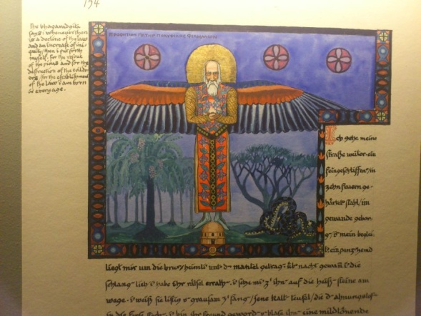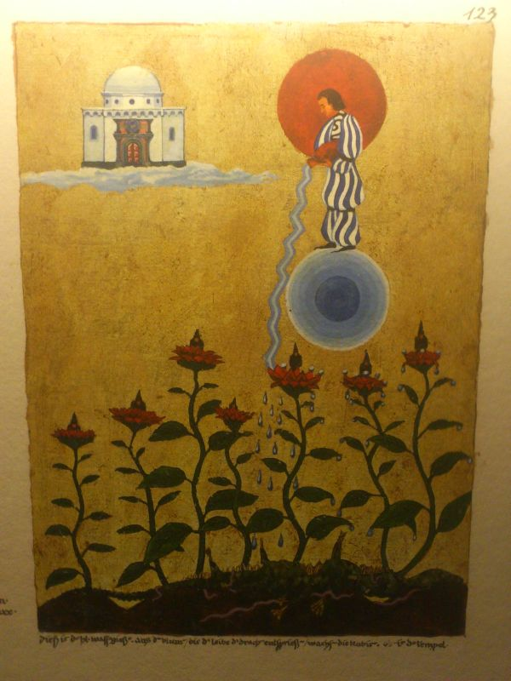
Afternoon tea then in the British Pavilion. And a meeting with Laura Gascoigne who told me about the talk she had attended with the young Italian curator, and his humility. She later sent me a text about the work in the Zimbabwe Pavilion....I was sitting in a vaporetto having escaped the Swarovski party (passing Marc Quinn’s work), chugging around Venice in the evening; I met an artist with a show in Mestre, so even then the possibility to network presented itself to me; we had a heartfelt, if brief, conversation.
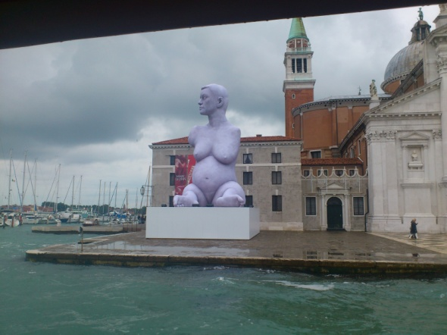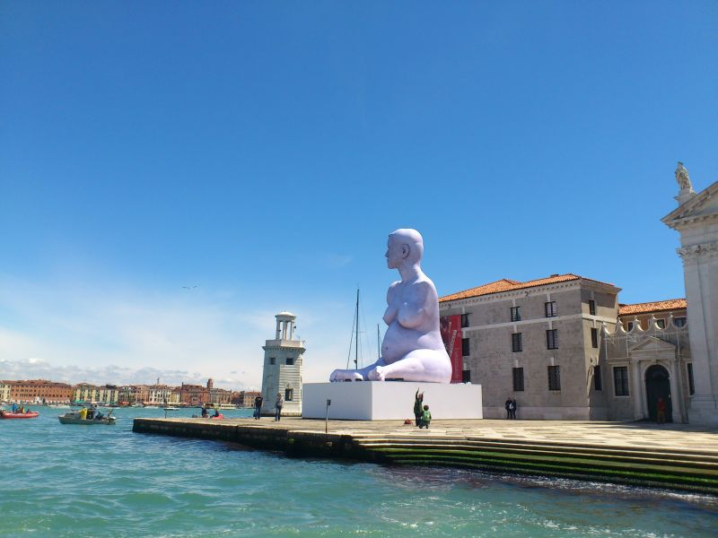
Across the lagoon at Zattere, the next morning, behind the great white Salute church (where I bought a poster of the black Madonna) I stumbled upon the Lichtenstein sculptures, in a fabulously restored yet crumbling palazzo. I touched the small pale pink bricks; their crumbling skin came away in my hand. The floor boards were narrow, new, elegant, immaculate, snaking in a perfect river towards the back of the space, which was higher - entering it felt like finding a cave full of brilliant glistening treasures. I have never been a fan of Lichtenstein’s work but I found this show full of evidence of a full scale grappling with the problems of being an artist – and the joys of resolution. The working drawings with their coloured tapes and measuring marks were earthy and strong; the plastic sculptures, an amalgam of giant lego and ancient Egyptian profiles, were more beautiful than I would have previously imagined.
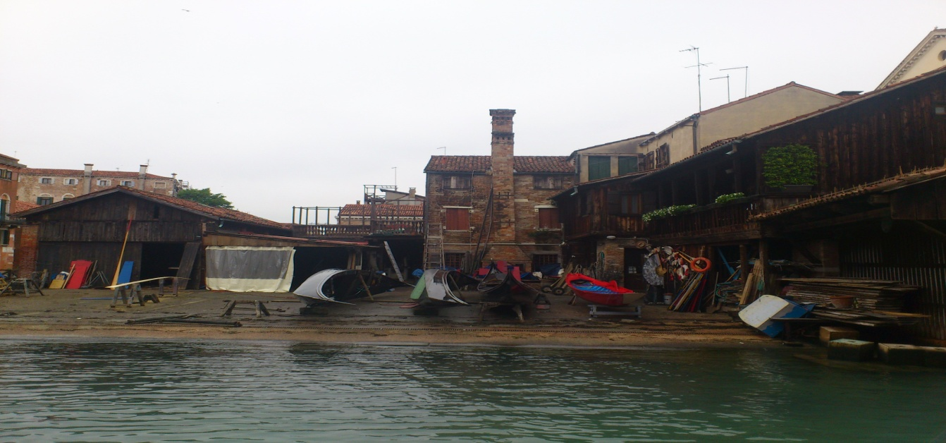
I ate my lunch leaning against a wall opposite the gondola repair yard; a woman approached with an ice cream cone. I saw that she had dropped her ice cream (it was windy) onto the ground. Minutes later an old man came along with a bag; he bent down, examined the melting ice cream, picked it up, and slowly began to eat it. I felt confused, sad, embarrassed, especially as earlier I had passed so many big fat motor launches which oozed with wealth.
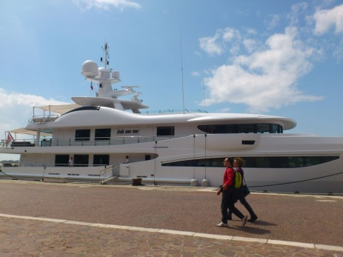 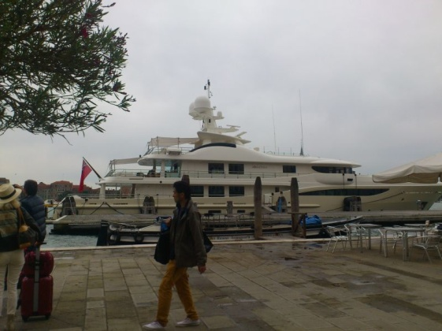 A giant motor launch called Addiction…
I visited the Portuguese pavilion – the floating one, the blues, the softness, the womb like interior, so obviously horizontal, floating, made by a woman. All was glitter and colour, I loved it for its sensuality and its love of material, stuff, and its over-the-top-ness. And it was all contained in a lovely old ferry boat, a kind of sister to the Venetian vaporetto; not a hideous super-sleek motor launch such as the super-rich were sporting.
Returning to the Giardini for lunch from a carrier bag, jammed into the cafe in the rain, feeling tired after a bad night in my second hostel (make sure you avoid youthvenicehome hostel, it’s anything but!) then across the little canal to the Hungarian Pavilion and the stark unexploded bombs, the Romanian performances.
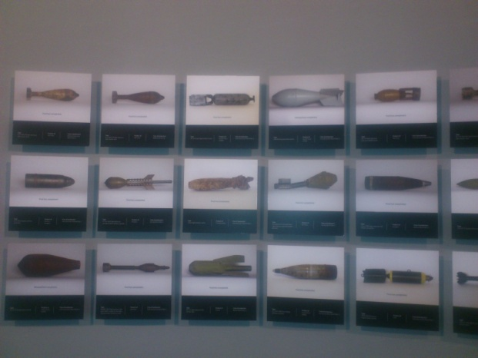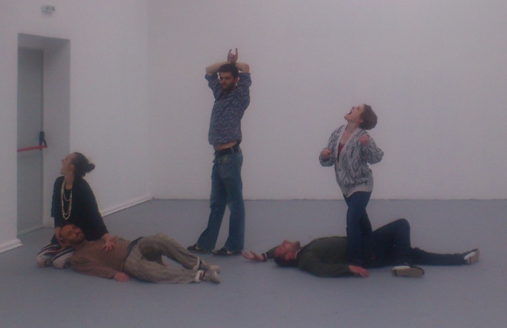
Some of my favourite works in the Giardini were by Guo Fengyi. She made large, column-shaped drawings in coloured ink. I loved these works, difficult to say why; but standing before them I felt as if I was at home yet was being shown something new, something unexpected, bodily, not clever or brain-arty and somehow simple, clear, pure.
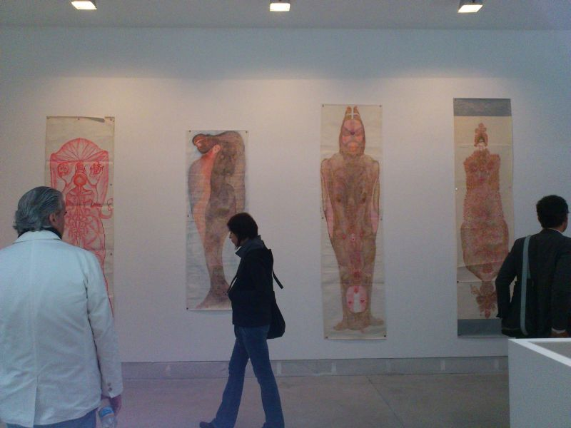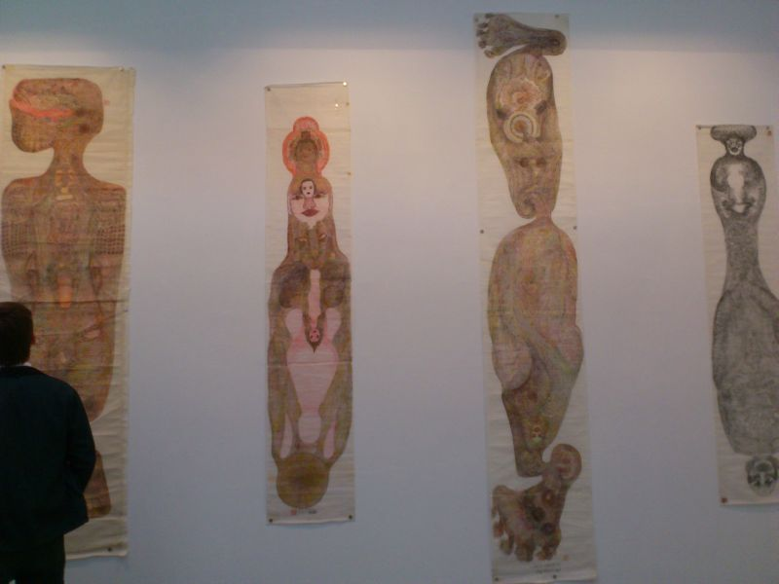

Not far from them in the central pavilion were little anonymous Tantric paintings which I also loved. Nameless, anonymous, found. Perfect.

I spent some time exploring Venice, going around collateral events: Alexandria Dementieva, her installation with its 3 light objects which react to various external stimuli curiously affecting – the relationship with breathing becoming visible and important.
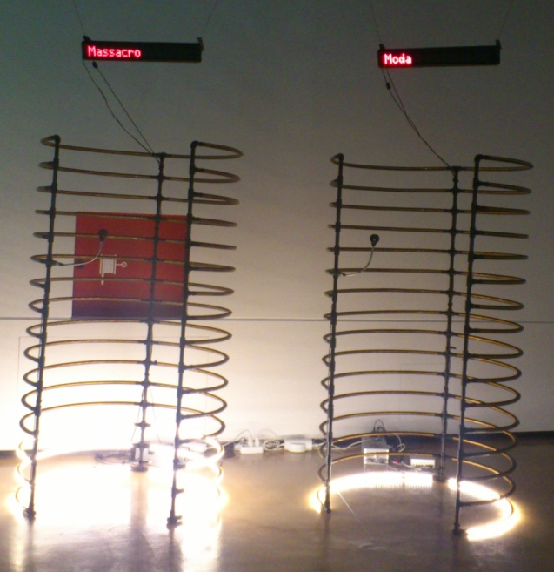

Rhizoma – the show of young artists from Saudi Arabia - was interesting. It is a culture I am learning about. According to Sara Raza, the curator, ‘this new and exciting scene is comparable to an actual rhizome, the ancient Greek word for the underground root of a plant that shoots its roots horizontally and vertically, against the force of gravity, possessing the ability to replant itself and form new roots’.
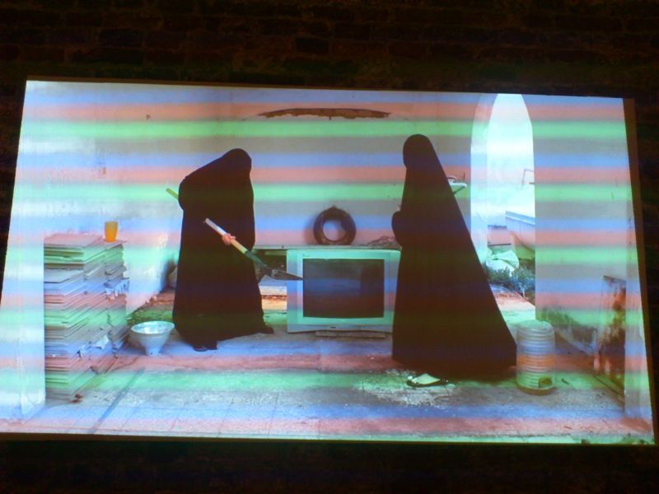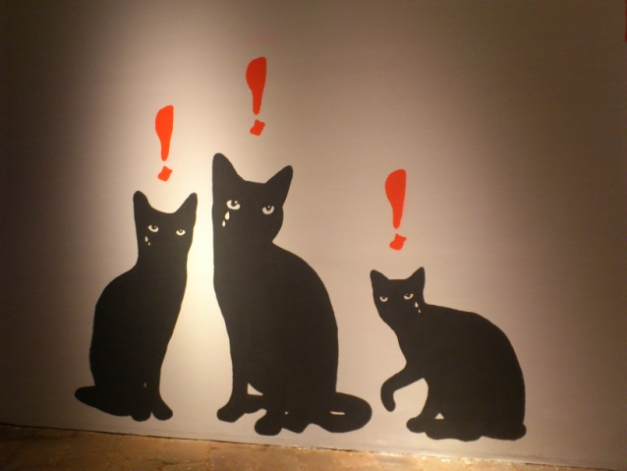
In the Zimbabwe Pavilion, just off the Riva degli Schiavoni, on my last full day, I met one of the artists
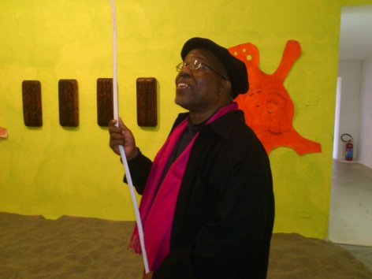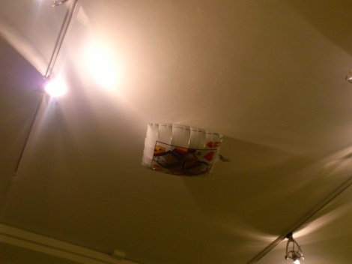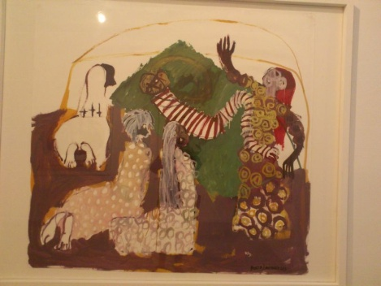
who told me about his work; how the balloons had been overinflated, how they represented the spirit, and were mean to be floating at chest height, not pressing against the ceiling; about how you mustn’t hurt a woman, or she will come for you, she will get you, at some level; he told me how this show represented the highest point of his life so far; how he invited me to the preview that evening, but when the time came, and I was sitting eating, alone, the first proper dinner for several days, and found that to my sorrow I just didn’t have any energy left... I regret it now, wish I had gone!
Near my second hostel in Castello the Church of San Antonin contains Ai Weiwei’s compelling installation Disposition.
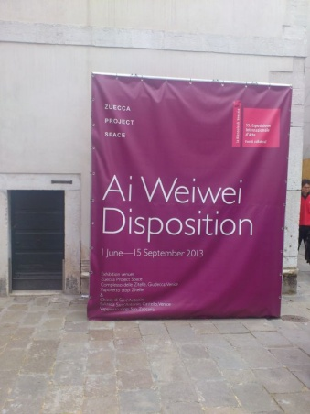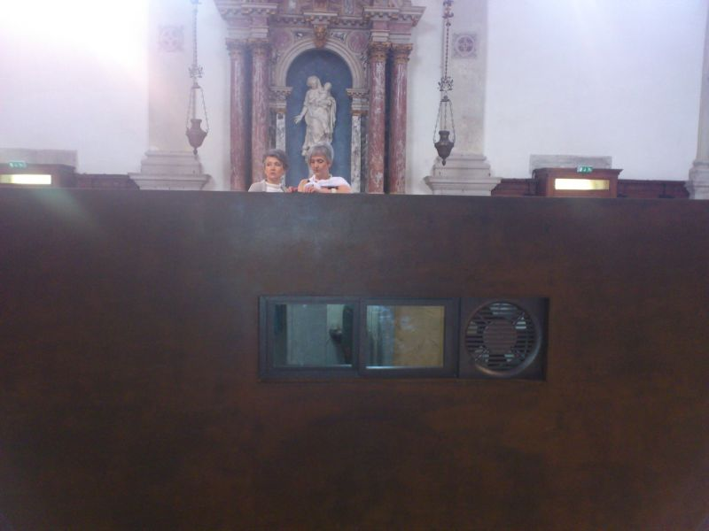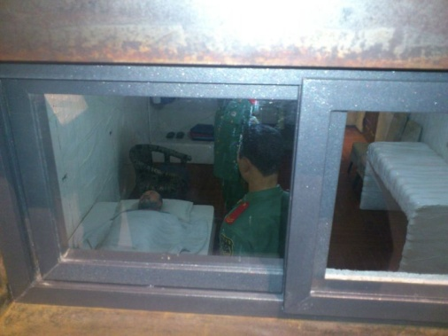
Heavy metal crates with half-life-sized models of the artist with Chinese guards watching him eating, being watched; sleeping, being watched, using the lavatory, being watched. You had to peer through little windows into the crates, the effect brought home the cramping, creeping unpleasantness of having one’s every move scrutinised, having not a moment to oneself. There was mental torture depicted here.
Some of my favourite works in the Arsenale were the ex – votos offerings depicting body parts which needed healing – for me any work which negotiates a movement towards the divine, especially in a contemporary art context, is interesting. These were from Poggibonsi, the Santuario di Romituzzo.
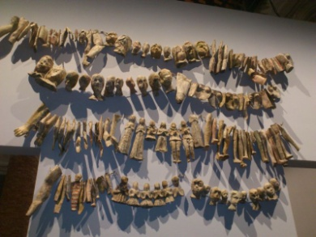 (papier-mâché, sixteenth – nineteenth century).
I found this sculpture in arte povera materials – what looked like sacking and pitch – arresting and moving, with its tears turned to teeth or horns or bones about to penetrate the chest of the figure.
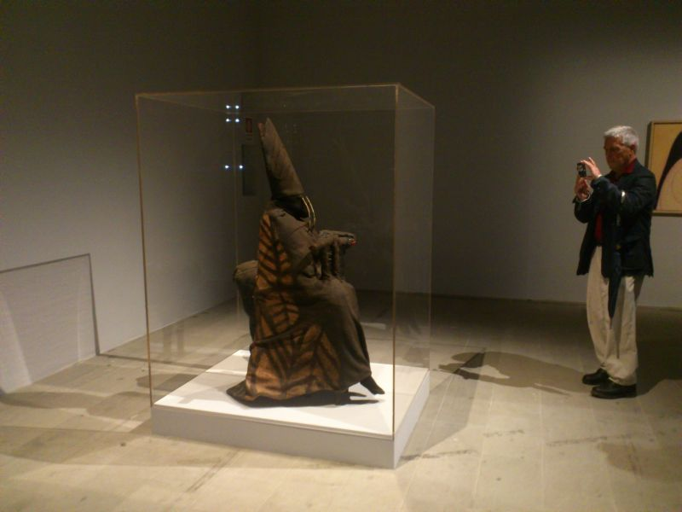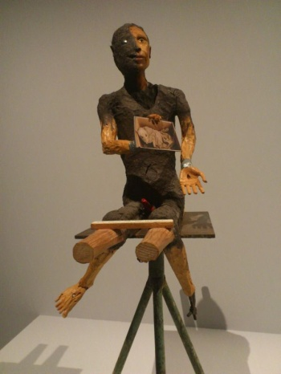
Black Pope and Black sheep by Miroslaw Balka Warsaw Jimmie Durham USA: Jesus, it’s about the sausage (it’s do or die).
In the Arsenale I was deeply saddened by Food, (Lebensmittel), the photo-montage work by Michael Schmidt – his commentary on industrial food production in Europe – an unflinching and bleak insight into the eating habits of advanced industrial nations (advanced?).
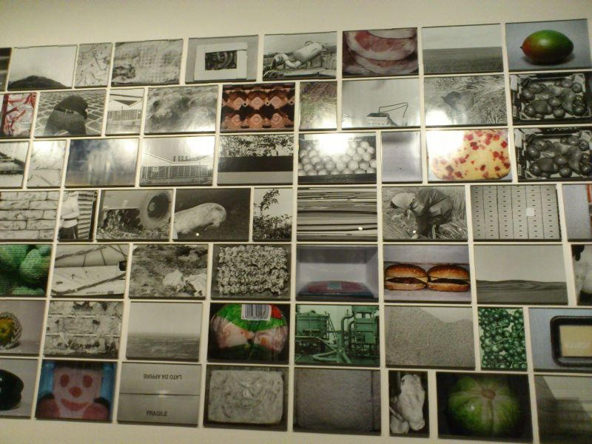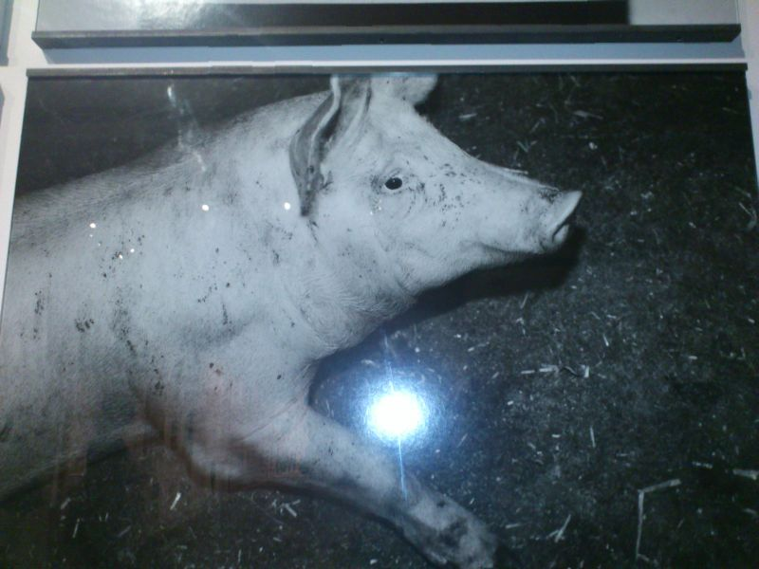

Having re-read this for the nth time I feel it is long enough – but there is far more to see than I have suggested here! I have far more photos, the huge and rich catalogue to read properly, and some short video sequences I am going to work into a little film. The memory which will stay with me longest I feel is probably the image of the little boat S.S. Hangover with her little brass band cargo playing –so beautifully- the haunting sad song slowly winding her way from the lagoon of the Arsenale into the canopy of the jetty. It brought to me a longing for home, for safety, for loved ones; the other visitors were like me - spell bound, rapt - and the ripple of spontaneous applause which greeted their mooring completed and dissolved the beautiful bubble which had been created.
I would love to return for another look. Next time I will allow more time, make better sleeping arrangements, book earlier, not travel by coach, and try not to feel overwhelmed by the sheer scale of the event. It was great to meet all the other a-n visitors and I rather regret not spending more time with them – but I felt driven to explore as much, see as much, as I could – so I travelled light and mostly alone around the shows. The buzz of being in Venice at the Opening weekend was fantastic; I loved feeling part of it.
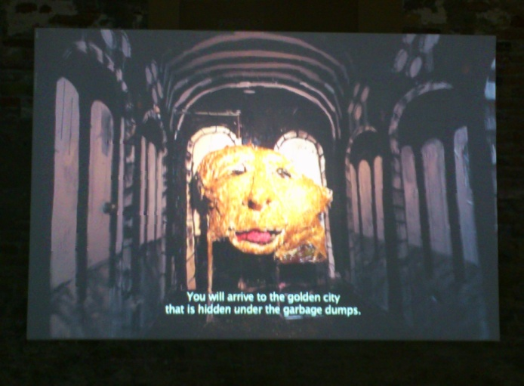 Leon & Cocina, Los Andes 2012, Chile.
Thank you a-n!! Kate Walters June 2013.

